**This R script file can be used for:**

1. Generate m value which doesn’t cause underflow
2. Generate r-tree based on different data nodes order.
3. Calculate the query time for query with/without R-tree structure and make comparison.

**Operating System:**

Only been tested on Windows System, however, the script should be working on any OS that support R.

**R Code Index:**

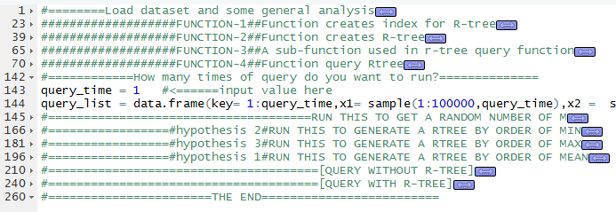

**How to use:**

1. Run first five code chunks to load dataset and functions
2. Change the input value to the times of query you want to run. (line 143)
3. Run code lines 142~144 to generate a list of queries
4. Run code chunk at line 145 to automatically generate a m value that won’t cause underflow
5. Run **one of three** code chunks at line 166,181,196 to produce a r-tree based on your m value
6. Run code chunk at line 210 to query without r-tree and output the query time
7. Run code chunk at line 240 to query with r-tree and output the query time

Notes:

For step 2, it takes more than 10 minutes to query without r-tree and more than one minutes to query with r-tree for one query on my laptop. So, it’s not suggested to have a long query list.

For step 4, you can generate your own m value by changing the code at line 162

For step 5, it takes about 10 minutes to generate r-tree on my laptop, so be please be patient at this step.

**Some Test Result:**



